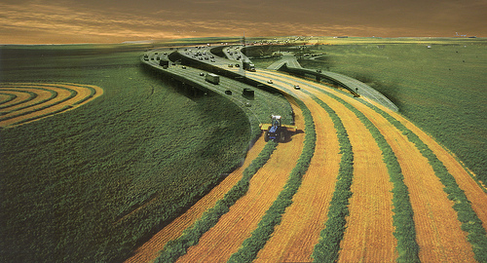

**ECON 492 – Senior Seminar, Section 6**

**Fall 2020 – *Analyzing Denver’s National Western Center as a Bridge Across Colorado’s Rural/Urban Divide***

Economics can be useful. Yet in the crunch to understand t‑statistics, elasticities, and exchange rates, this fact can often get lost. The final course in the economics program is therefore designed to apply your economics toolbox to the challenges and opportunities facing both Colorado and the rest of the nation. Colorado’s economy has long been among the most dynamic in the country, due in large part to the state’s mix of highly productive and amenity-rich rural areas and its innovative, attractive urban corridor. But Colorado, like much of the country, is experiencing uneven growth. Rapid urban growth is a key driver of the state’s economic expansion, as the Front Range in particular benefits from strong inflows of educated, creative workers. But this same growth has put upwards pressure on housing prices, led to infrastructure congestion, and created a more skill-intensive labor market.

Colorado’s rural areas also face a mix of opportunities and challenges. The state’s agricultural sector is among the most productive in the country, and is also highly diverse, comprising not only crop and livestock production but also substantial employment in marketing, wholesale, and innovative research in crop and animal sciences. Beyond agriculture, many of Colorado’s rural areas benefit from natural resource amenities. The state’s rural areas are also highly entrepreneurial, with self-employment rates substantially higher than the Front Range – and a third greater than rural areas nationwide. Yet many rural Colorado counties, especially those heavily concentrated in agriculture and natural resource extraction, have experienced declining incomes and net out-migration.

Denver’s National Western Center (NWC) redevelopment – in which CSU plays a major role – sits squarely at the intersection of these regional trends. As an urban space with an economic and cultural heritage deeply rooted in agriculture and natural resources - industries more concentrated in the state’s Eastern Plains and Western Slope - the NWC presents a unique opportunity to bridge the so-called “rural-urban divide.” Indeed, one of the main aims of the National Western Center’s development plan is to “serve as a catalyst for the New West and a new way of thinking.”

The capstone will explore innovative linkages between Denver’s urban Front Range to the entrepreneurial rural parts of the state. Colorado is uniquely placed to be a national leader in addressing the now widely-recognized gaps between rural and urban areas, and your work will play a critical role in building these bridges.

Instructor: Prof. Stephan Weiler

Prerequisites: Senior status, ECON 304, 306 and 335 (or concurrent registration)

Section 6, CRN 65364: 2:00-3:15 PM TR, Eddy 113

C:\Program Files\Microsoft Office\MEDIA\CAGCAT10\j0199036.wmfC:\Program Files\Microsoft Office\MEDIA\CAGCAT10\j0285698.wmf

**ECON 492 – Senior Seminar, Sections 2 & 5**

**Fall 2020 - *Sports Economics***

In this seminar we will examine the application of economics, particularly microeconomics, labor economics, and public finance, to sports issues, such as the relationship between player salaries and performance, salary caps and competitive balance, stadium subsidies and team success, spending and winning in college sports. Seminar participants will complete a research project (paper and presentation) that applies economic theory and uses data to explain observed behavior in sports.

Instructor: Prof. Nancy Jianakoplos

Prerequisites: Senior status, ECON 304, 306 and 335 (or concurrent registration)

Section 2, CRN 61936: 9:00-9:50 AM MWF, EDDY 108

Section 5, CRN 64228: 11:00-11:50AM MWF, EDDY 118

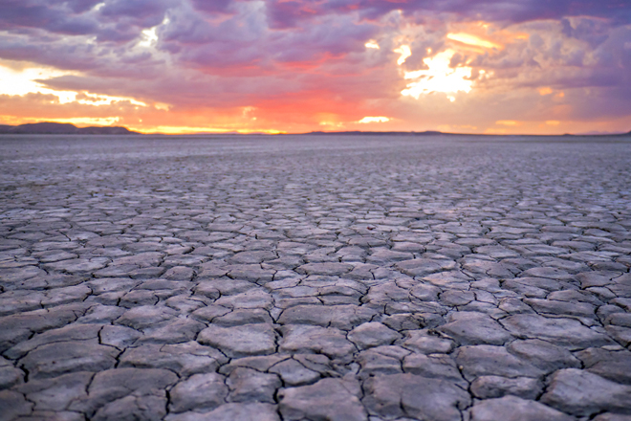

**ECON 492 – Senior Seminar, Section 1**

**Fall 2020 - *The Economics of Climate Change***

However you look at it, the prospect of human-caused climate change presents an enormous policy challenge that has been the subject of intense international debate for almost 30 years. While uncertainty persists regarding many features of the problem, the possibility of dire consequences cannot be ruled out. Meanwhile, despite numerous efforts to reduce emissions of carbon dioxide and other heat-trapping greenhouse gases, global emissions continue to increase at a rate of several percent per year. The field of economics provides powerful conceptual and empirical tools for understanding the key policy obstacles and for devising a response that addresses these obstacles in a realistic way. In this class, students will work together in groups to survey and analyze various central considerations in the economics of climate change. The course will culminate in a poster-sharing session in which students share with each other the findings of their research.

Instructor: Prof. Terry Iverson

Prerequisites: Senior status, ECON 304, 306 and 335 (or concurrent registration)

Section 1, CRN 67434: 3:30-4:45 PM TR, CLARK C363